Name: Joseph Peck

Student ID: 01462732

**AI in Football:**

**How AI is currently used to aid refereeing in football.**

Word Count: 1304

**Introduction**

Football, a sport steeped in history and culture, is no stranger to its fair share of controversial moments stemming from refereeing decisions over the years. In 2014 the football world was first introduced to the concept of a referee’s judgement not being the final say, with AI aided goal line technology being first introduced at the World Cup in Brazil. Following this introduction, in 2017 the Video Assistant Referee (VAR) system was first introduced with the Italian and German leagues to be the first to implement the VAR system. The introduction of the AI and the VAR system promised fans that the human error in key moments of a football game would be significantly reduced. However, the implementation of VAR and AI has received mixed reviews from fans. This essay aims to be explain and explore how AI has been used to improve on field refereeing decisions.

**Goal Line Technology**

According to the laws of football, the entire ball has to cross the goal line for the goal to awarded. Before the introduction of goal line technology, the referee and assistant referee were relied upon to monitor the goal area to determine if the ball had fully crossed the line. As you can imagine, this is subject to multiple factors on the pitch which can make it hard for the correct decision to be made, the referee’s line of sight and angle on the ball, the distance between him and the goal and many more, all of this contribute to potential human error. One of the many incidents of human error, was between a game between England and Germany in the 2010 world cup quarter finals where English player Frank Lampard’s equalizing goal was wrongfully not awarded although it had clearly crossed the line to everyone watching at home.

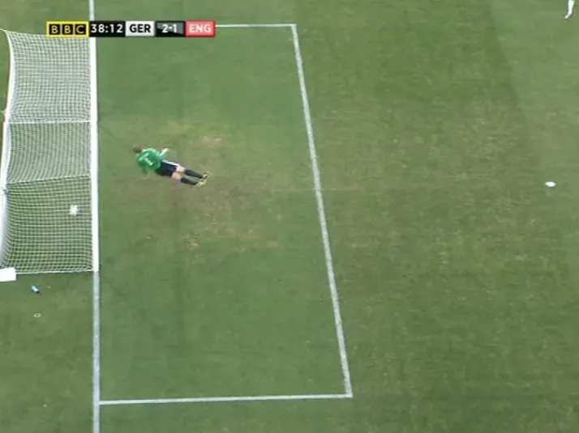

Figure 1: Lampard’s infamous “goal” incident against Germany that could have been prevented with AI

In a sport where goals can be hard to come by a single goal could heavily swing the tides of a game, a more reliable method to discern if the ball had crossed the line was desperately needed. Taking cues from other sports such as tennis and cricket’s use of Hawk-Eye, the FIFA and IFAB associations approved the use of similar technology at the next World Cup in 2014. Stadiums were equipped with 14 high-speed cameras under the roof with 7 aimed at the goals (Inside FIFA, 2022). aThe high speed cameras utilize triangulation to determine the ball’s exact position by tracking the pixels of the ball in each frame. This data is then used to generate a 3D image of the balls position in relation to the goal line and is displayed to both the fans watching at home and those in the stadium (WIPO, 2010). Referees are notified of the goal line technologies decision through a watch that they wear within a second of the decision being made.

Since its introduction, goal line technology has reduced the number of controversial goal decisions by 98% with each goal decision taking less than a minute to be concluded (Linder, 2024). While its use has not been completely spotless with a few notable cases of failures to come to the correct decision, goal line technology has provided football a more or less objective answer to the age old question of did the ball cross the line or not.

**VAR**

Another system that has been implemented into football to reduce the human error and ensure the correct decisions are made on the field is the video assistant referee system or VAR. In essence, VAR allows for the play in question to be reviewed by a group of referees on duty, they then inform the main referee on the field if they think he or she might have made a mistake and provide the appropriate replay for the on field referee to review if required.

In its initial introduction, VAR’s artificial intelligence usage was relatively minor, using similar tracking data as goal line technology. One of the most common cases for the use of VAR is to determine if a player should be deemed offside. An attacking player is deemed offside if a part of their body that can be used to play the ball is beyond the last opposing defender at the moment the pass is played to them. A very complicated rule that has multiple variables to keep track of. First the referee would have to know the exact instant that the ball was kicked by the passer, next the assistant referee by the side of the pitch would have to be exactly in line with the last defenders and identify which defender’s limb to consider as in order to judge if the attacking player is to be deemed offside in the moment that the ball was passed to him.

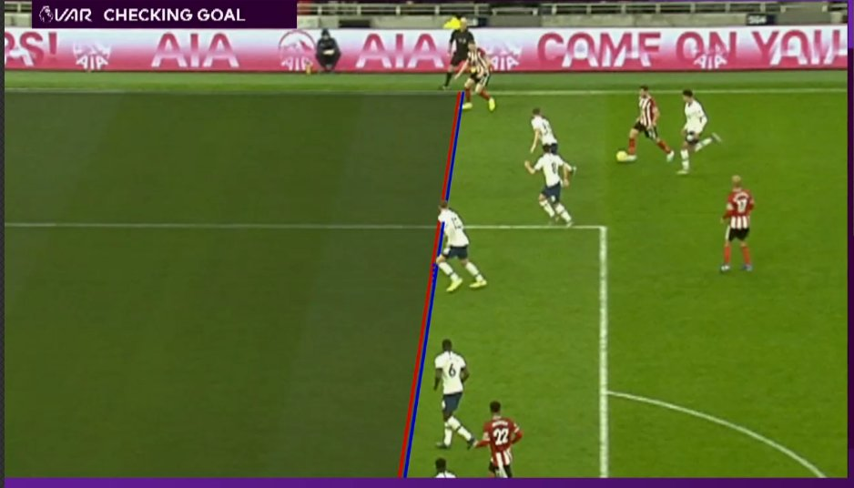

Figure 2: Example of VAR reviewing the goal scored to determine if the player was onside

Thankfully this complicated process is made a lot simpler through the use of AI and VAR, the tracking data provided by the AI systems allows for the VAR officials to automatically identify the camera that provides the best angle to judge the issue at hand. The system provides freeze frames for referees to examine to determine when exactly the pass is played and draws millimetre accurate perpendicular lines aligned with the relevant players to judge if the attacking player is to be deemed offside as can be seen in Figure 2. However, even with the assistance of AI, this review process often takes far too long leaving both fans and players in suspense about the outcome of the review and potentially ruining the adrenaline inducing moments that football is loved by many for.

In response to this criticism the semi-automated offside technology or SAOT was developed. SAOT tracks each of the players and the ball 200 times per second with over 10,000 surface points including 29 data points on each individual player, this has allowed them to greatly reduce the time taken for offside decisions to be made. When it was first introduced at the 2022 World Cup in Qatar, it has reduced the time taken for offside decisions by 31 seconds while also producing a virtual recreation of the two players involved in the decision instead of imposing lines onto the replay allowing for easier understanding for the spectators. (Hu and Middling, 2024)

So how does SAOT work? SAOT uses Convolutional Neural Networks (CNNs) which is a deep learning algorithm that was developed to understand and analyse videos and images, by using layers to identify important features within the media. CNNs are also capable of self-paced learning allowing it to train itself for what it is to look out for on within the data that it is being provided. In the use of the football replays, the CNNs are trained to recreate the exact points of the players body and position of the ball through 3D renderings of the data as can be seen in Figure 3. (Hu and Middling, 2024)

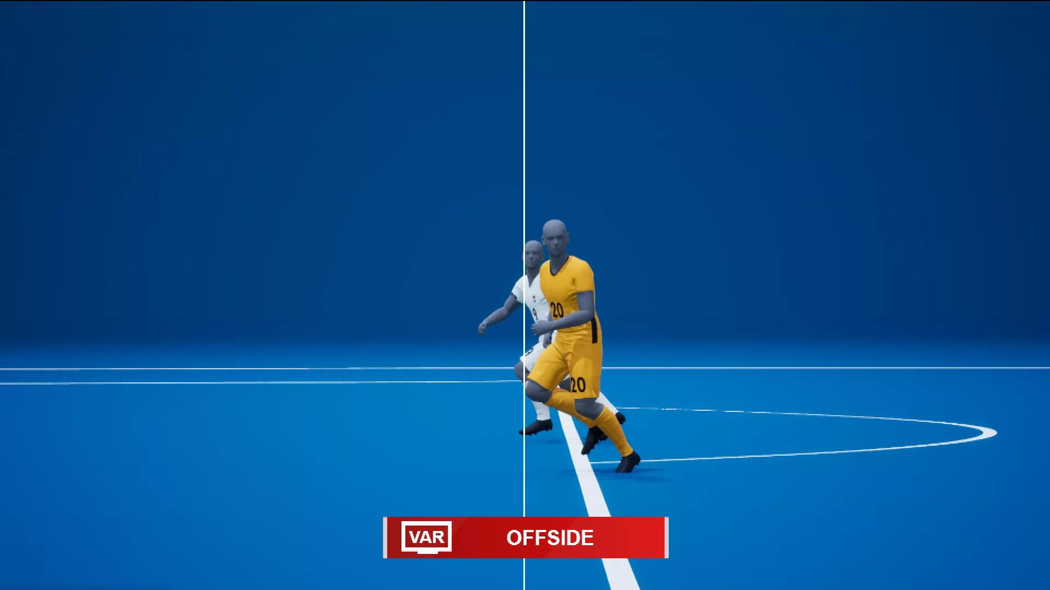

Figure 3: Example of SAOT reviewing the goal scored to determine if the player was onside

**Conclusion**

Overall, although the implementation of AI over the last decade of football not been perfect, its improvements over time can be seen through the implementation of SAOT at the 2022 World Cup. With leagues such as the English Premier League beginning to implement the SAOT system into their competitions in the 2024/2025 season it shows the willingness from the decision makers to implement more AI measures to improve the quality of refereeing in football. Not only that, but the development of SAOT shows that the decision makers are also listening to the feedback of the general football community regarding the flaws of the AI system which provides a good trajectory for AI’s use within football.

**Bibliography**

“Goal-Line Technology – Getting It Right.” *WIPO*, Aug. 2010, www.wipo.int/wipo_magazine/en/2010/04/article_0001.html#:~:text=A%20sensor%20suspended%20in%20the,has%20crossed%20the%20goal%20line.

“Goal-Line Technology.” *Inside FIFA*, 8 Nov. 2022, inside.fifa.com/technical/football-technology/football-technologies-and-innovations-at-the-fifa-world-cup-2022/goal-line-technology.

Hu, Shanfeng, and Mark Middling. “Expert Comment: How Ai Can Dramatically Reduce the Time It Takes to Make Var Offside Calls in Premier League Football Matches.” *Northumbria University*, 30 Aug. 2024, www.northumbria.ac.uk/about-us/news-events/news/expert-comment-how-ai-can-dramatically-reduce-the-time-it-takes-to-make-var-offside-calls-in-premier-league-football-matches/.

Linder, Jannik. “Technology in Football Statistics: Advancements Transforming the Beautiful Game.” *Technology In Football Statistics Statistics: ZipDo Education Reports 2024*, 26 July 2024, zipdo.co/technology-in-football-statistics/.